**Quang An Pham - 24868275**

**Table of Content**

* Executive summary
* Data Preparation
* The Statistical Method.
* The Analytical Method
* About VBA
* All Main Categories.
* Statistics.
* Analytics
* Export.
* Import
* Dashboard.
* Dashboard I
* Dashboard 2
* Story Point 1: The Overall Trend
* Story Point 2: Overall catefory3
* Story Point 3: Detail òf category 3
* Story Point 4: Import Trade Session.
* Story Point 5: Export Trade Session.
* Summary and Conclusion..
* Summary of Advantages
* Dashboard
* Storyboard
* Conclusion..
* recommendation

**Introduction**

This paper relies on an examination and interpretation of the Australian international trade dataset, sourced from the Australian Bureau of Statistics (ABS). The trade efficiency of every nation is significantly influenced by their imports and exports, and Australia is no exception to this pattern.

The objective of this thesis is to showcase a comprehensive understanding of various types of information and data related to Australian international trade. To unveil patterns and unravel data narratives within the dataset, statistical data, and analytical patterns will be employed, along with diverse visualization techniques.

The Australian International Trade dataset, compiled from ABS statistical data, spans over 30 years, from 1988 to 2022. This dataset encompasses import and export statistics, along with 10 major categories and 67 sub-categories. Within each sub-category, the productivity and resource performance of various industries are examined.

The 10 major categories include:

* Category 0: Food and Live Animals
* Category 1: Beverages and Tobacco
* Category 2: Crude Materials, Inedible, Except Fuels
* Category 3: Mineral Fuels, Lubricants and Related Materials
* Category 4: Animal and Vegetable Oils, Fat and Waxes
* Category 5: Chemicals and Related Products, nes
* Category 6: Manufactured Goods classified chiefly by Material
* Category 7: Machinery and Transport Equipment
* Category 8: Miscellaneous Manufactured Articles
* Category 9: Commodities and Transactions not classified elsewhere in SITC

Note: The category chosen for further analysis is Category 3: Mineral Fuels, Lubricants and Related Materials

**Data preparation**

The preparation of data holds significant importance as an initial step, as it ensures that the data is organized more meaningfully for subsequent visualization and analysis. It is evident that there exist substantial variations in the magnitudes of data points throughout the dataset, ranging from a few million to thousands of millions across different categories and sub-categories. This variance poses challenges in effectively visualizing the data.

To address this issue, two distinct patterns, namely the statistical and analytical, will be established. These patterns are designed to streamline the data and facilitate a more in-depth analysis.

**Statistic approach**

The statistical approach encompasses two primary techniques for data preparation, with one focusing on managing the main categories and the other addressing the sub-categories within each main category. Both techniques share a common principle of comparing a 'child' value to its 'parent' value. For example, in the context of a main category, the monetary value of imports is compared to the total value of imports for that year. The resulting division of these values is then expressed as percentages in the statistical analysis. Similarly, for sub-categories, the monetary value of sub-category imports is compared to the main category's value of imports, and the division of these values is also represented as percentages in the statistical analysis.

The statistical pattern aids in determining the proportion or percentage of each category's import or export relative to the total import or export for each year. The percent proportion formula for each category (i=0 to 9) is applied



Likewise, the same part/whole formula is employed to ascertain the percent proportion for each sub-category's import or export concerning its parent category's import or export. Consequently, all the data are standardized into percentage format and placed on a consistent scale.

**The Analytics Approach**

The analytics approach diverges slightly from the statistical method, as it involves comparing 'parent' and 'child' values based on the year, and the final outcome is expressed in percentages. To illustrate, the import value of a main category in 1989 is divided by the corresponding category's value in 1988, and the resulting percentage is incorporated in the analytics. This process is mirrored for sub-categories. Given that the dataset commences in 1988, this year is considered the base year and assigned a percentage value of 100%. Subsequent percentage calculations are then derived relative to this base year.

What distinguishes the analytics approach from the statistical one is that, in the case of the main category, the parent value is unrelated to the total value, and in the case of the sub-category, it is disconnected from the main category value.

The analytical pattern serves the purpose of gauging the year-over-year change for a specific category or sub-category. The calculation of the yearly change involves simply dividing the data for a specific category or sub-category in the current year by the corresponding data from the previous year.



where d stands for the data and t = 1988, 1989, … , 2021.

**Visualization technique**

This section will delve into the diverse visualizations conducted for both the statistical and analytical approaches applied to the dataset.

**Overview of export and import**

According to The Treasury (2004), a Google search on exchange rates reveals that the Australian dollar experienced a climb from US$0.59 per AUD in January 2003 to US$0.74 in December 2003. Conversely, in 2014, the Australian dollar declined from US$0.87 in January to US$0.81 in December, marking a part of a more extended downward trend. The fluctuating Australian dollar plays a significant role in export earnings, whereby a falling dollar increases earnings, as exports sold in foreign currencies can be converted into more AUD. Conversely, a rising Australian dollar reduces exporter earnings but makes imports more affordable, thereby increasing demand for these goods. Noteworthy anomalies include a smaller spike in both imports and exports in 2009, leading to a subsequent rise and fall in the year-on-year value in 2009-2010. Another significant outlier is 2020, witnessing considerable drops in year-on-year imports (-4.7%) and exports (-6.9%), likely due to the impact of the coronavirus pandemic. These figures returned to historical trends in 2021, resulting in above-average year-on-year growth. Consequently, 2022 recorded the highest increase in imports at 125.33% and a surge in exports at 129.33%, marking the highest levels since 2008.

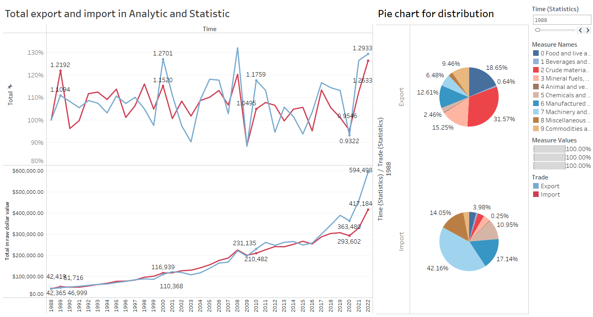

Figure 1:

Utilization of Interactive Filtering:

This graphical representation also provides an opportunity to delve into the subcategories comprising Australia's trade, facilitated by the compact pie charts positioned to the right of the dashboard. These pie charts dynamically showcase the evolution of import and export compositions over time, offering supplementary insights alongside the trade value chart. They are interactive, enabling reciprocal filtering between the charts. By clicking on a specific year on the trade value chart (labeled as 'A'), users can discern the breakdown of imports or exports for that particular year in the accompanying pie charts.

Interactive and Playable Dynamic Charts:

Incorporated into the visualization are dynamic charts that empower users to observe the changing composition of trade over different periods. This functionality introduces a dynamic play feature, allowing users to navigate through a sequence of "pages" representing various years. This dynamic play attribute is integrated into the aforementioned pie chart (illustrating all subcategories, color-coded by primary category as mentioned above), with a corresponding tree map appearing below. Unfortunately, due to the limitations of static images in this report, the interactive playback cannot be demonstrated visually.

**All main categories**

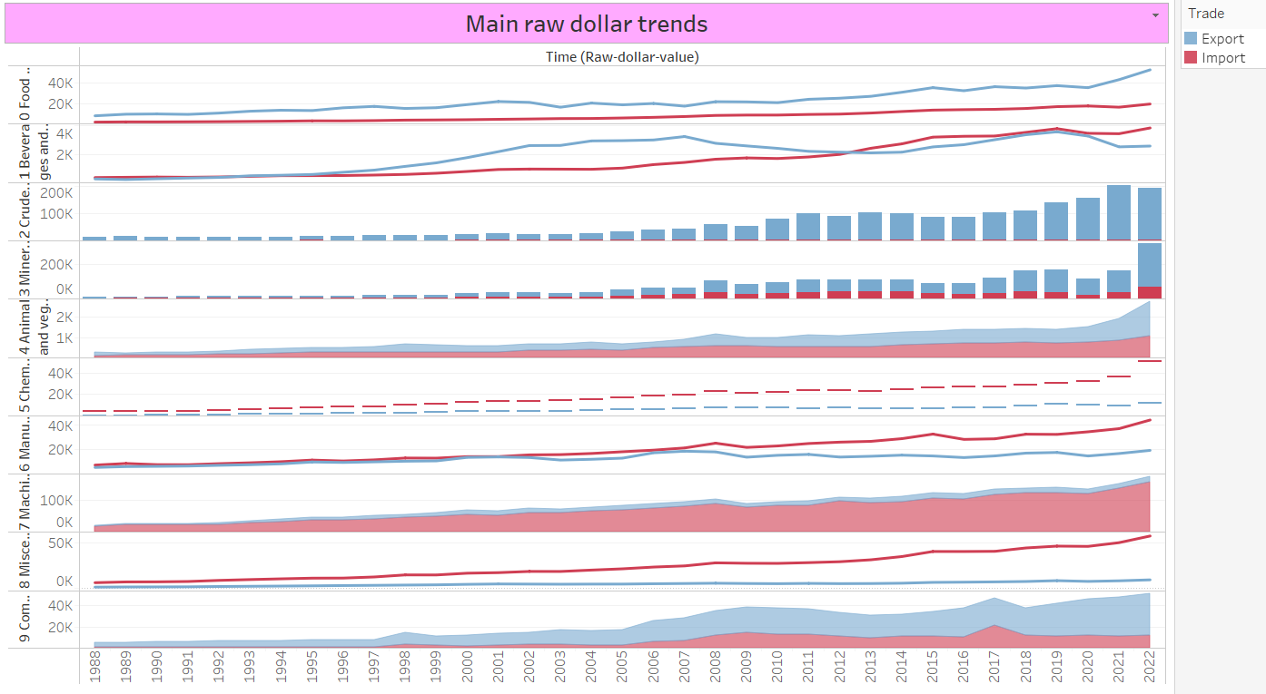

Figure 2:

A consistent upward trend is evident across all categories, indicating a gradual increase in both import and export volumes. Notably, in half of the categories, namely categories 5, 6, 7, and 8, import volumes surpass export volumes. Interestingly, Category 2, encompassing Crude Materials, Inedible, Except Fuels, exhibits remarkably low import figures, underscoring Australia's strength in managing its crude materials and inedible resources. Conversely, Category 7, comprising Machinery and Transport Equipment, records exceptionally high import figures, reflecting Australia's reliance on imported machinery and equipment manufacturing. This highlights a notable contrast in Australia's self-sufficiency in crude materials versus its dependence on imported machinery. Despite these variations, the overall trajectory for Australia's import and export activities is one of continuous growth and increasing strength.

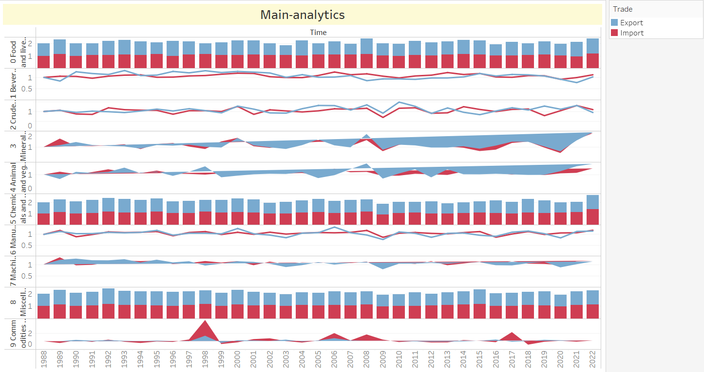

Figure 3: The Analytical analysis of main categories

The trade volume soared to A$594,498 million, registering an impressive increase of approximately 1,300.03% compared to A$42,365 million in 1988. A pivotal period occurred in 2008-2009 when both import and export trade volumes witnessed a decline due to the global economic crisis. Similarly, from 2019 to 2020, amidst the global COVID-19 pandemic's impact, Australia experienced another simultaneous downturn in import and export trade volumes, followed by a subsequent rebound. Notably, since 2016, exports have consistently outpaced imports, signaling an expanding gap. This shift is attributed to heightened international demand for Australian goods, particularly from China, as reported by Containers (2020) and Ker (2017). Predictions by He (2023) suggest that with the improvement in Sino-Australian relations, Australia's exports to China will continue to rise.

Certain categories consistently witness higher import trade volumes than export trade volumes, including 5 Chemicals and related products, nes, 7 Machinery and transport equipment, and 8 Miscellaneous manufactured articles. This discrepancy is attributed to Australia's unique geographic position, necessitates reliance on imported manufactured goods (Leahy, Palangkaraya, and Yong, 2009). Conversely, categories such as 0 Food and live animals, 2 Crude materials, inedible except fuels, 3 Mineral fuels, lubricants, and related materials, and 9 Commodities and transactions not classified elsewhere consistently maintain higher export trade volumes than import trade volumes. This is due to Australia's abundant mineral resources meeting global export demand (Government of Australia, 2018) and a historical tradition of exporting grass-fed beef, sheep navels, and live cattle and sheep (Shone, 2022).

For categories 1 Beverages and animals, 4 Animal and vegetable oils, fats and waxes, and 6 Manufactured goods classified primarily by material, there is a reversal in import and export trade volumes, warranting further investigation. In the early and late stages, the import trade volume of beverages and animals exceeded the export trade volume, but since 1993, the export trade volume has consistently led. The difference between export and import trade shares reached its pinnacle at 1.7% in 2003 but was later surpassed by import trade volume until 2012. Factors such as the peak in the Australian dollar-to-euro exchange rate in 2012, as reported by Bloomberg.com, increased the import of European wines, altering the trade volume dynamics for beverages. The trade volume for animal and vegetable oils, fats, and waxes reveals closely matched import and export data, with occasional instances of one exceeding the other. In 1996, export percentage surpassed import percentage by 0.15%, but by 2008, import data had reversed the trend, exceeding export data by 0.1%. Additionally, although manufactured goods classified primarily by material have generally exhibited higher export trade volumes, a brief period in 2000 saw export percentage reaching 11.3%, only to decline to 3.2% by 2022, while import data remained stable around 10%.

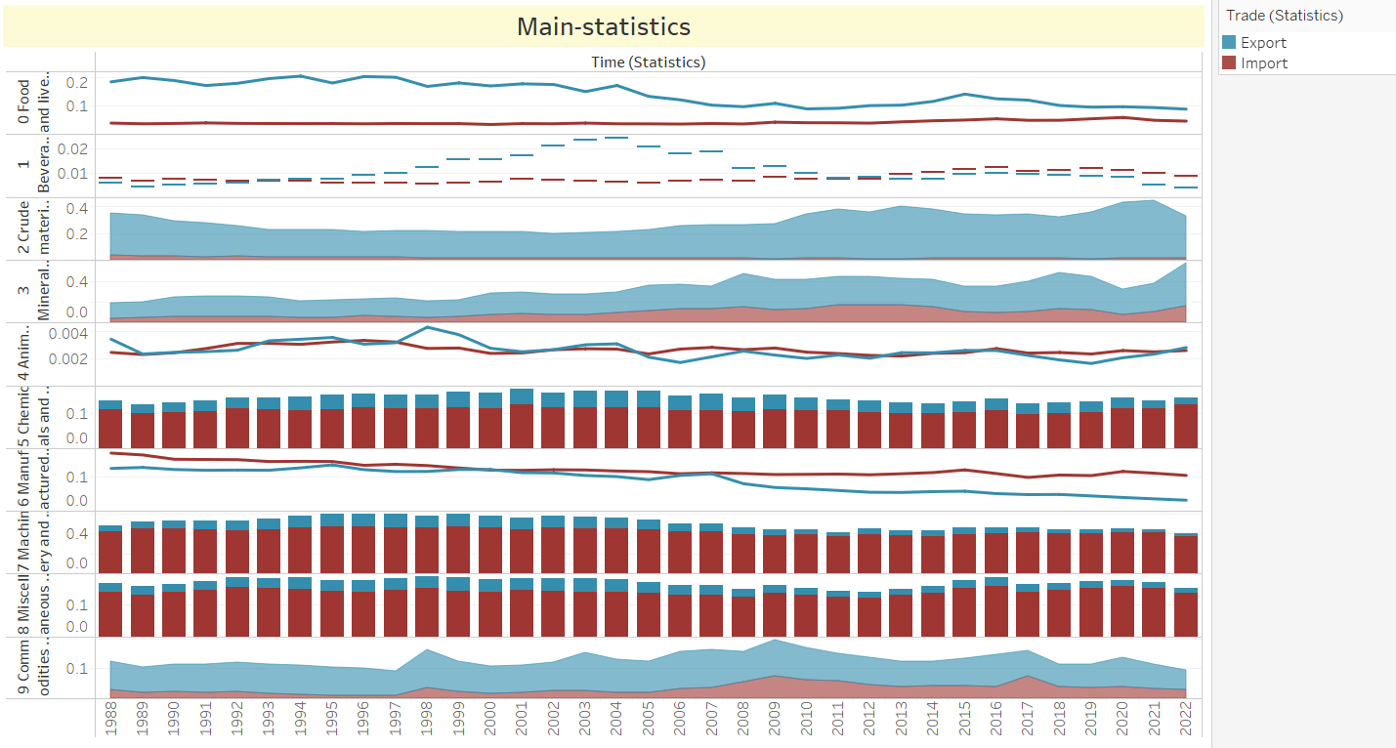

Figure 4: The statistical analysis of main categories

As evident in Figure 4, the rate of change in total imports and exports exhibits consistent similarity throughout the period from 1988 to 2022, showcasing a notable correlation with no significant lead of one over the other. Notably, during the global economic crisis in 2008-2009, both import and export trade experienced a simultaneous 88% drop in the annual change rate. However, the data from 2019 to 2020 reveals a divergence influenced by external factors, particularly the impact of the COVID-19 pandemic. The annual change rate of export trade volume decreased by 20%, whereas the annual change rate of import trade volume only decreased by 8%.

Figure observations highlight that the curves for 3 Mineral fuels, lubricants, and related materials, and 4 Animal and vegetable oils, fats, and waxes consistently run in close proximity, with both their import and export change rates in 2022 surpassing those in 1988. Between 2008 and 2009, exports for categories 3 and 4 witnessed significant drops of 105% and 80%, respectively, due to the economic crisis. Notably, for categories 3, 4, 6, and 7, the annual change rate of import and export trade volume during this period experienced a decline, significantly influencing the overall annual change rate of total import and export trade.

An evident inflection point in the figure occurs in 1998 for Commodities and transactions not classified elsewhere in the SITC. From 1997 to 1998, the annual change rate of import trade surged from 122% to 367%, nearly tripling. This significant increase is attributed to the reduction of most tariffs to less than 5% in 1998, as reported by the WTO | Trade policy review - Australia 1998 (1998). This tariff reduction substantially stimulated import trade growth, leading to a subsequent decrease in the annual rate of change in imports to 64% in 1999 due to excess demand.

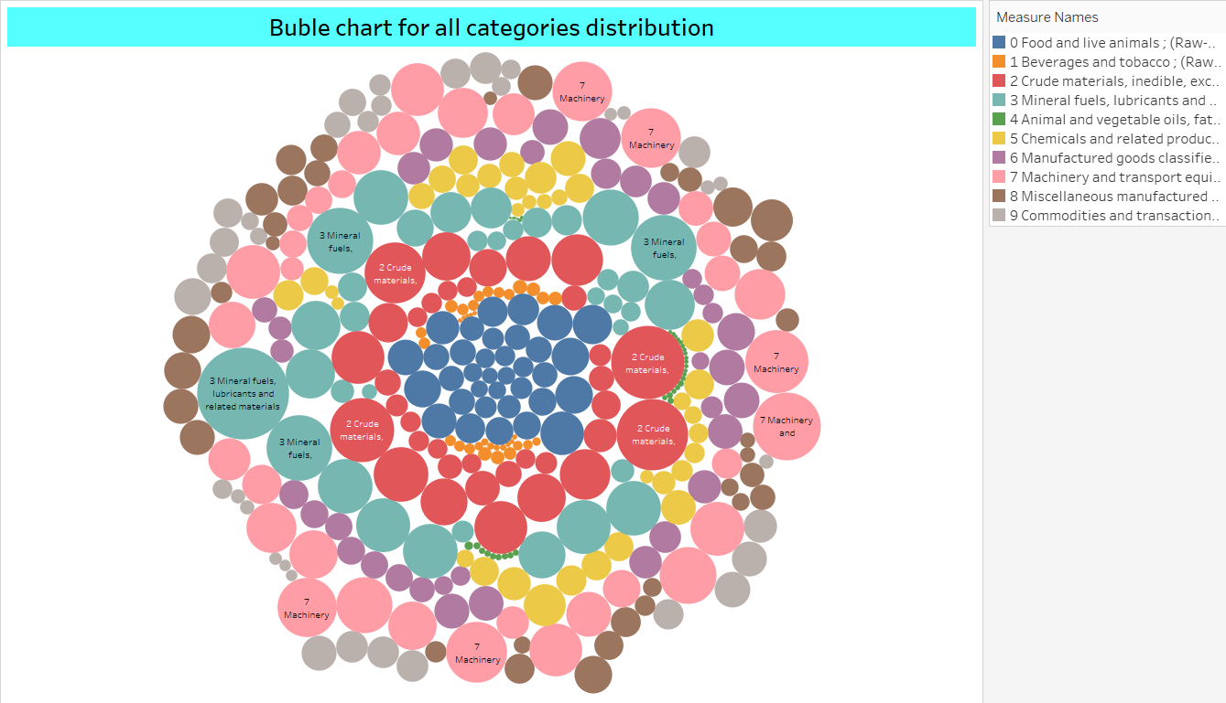

Figure 5:

Figure 5 introduces the utilization of a bubble chart as an alternative visualization method to enhance the depiction of Australia's primary trade sources from 1988 to 2022. This technique highlights the top three contributors: (2) Crude Materials, Inedible, Except Fuels; (3) Mineral Fuels, Lubricants, and Related Materials; and (7) Machinery and Transport Equipment. The bubble chart provides a nuanced perspective, visually articulating the significance of these categories in Australia's trade landscape over the specified period, contributing to a more comprehensive understanding of the evolving trade dynamics.

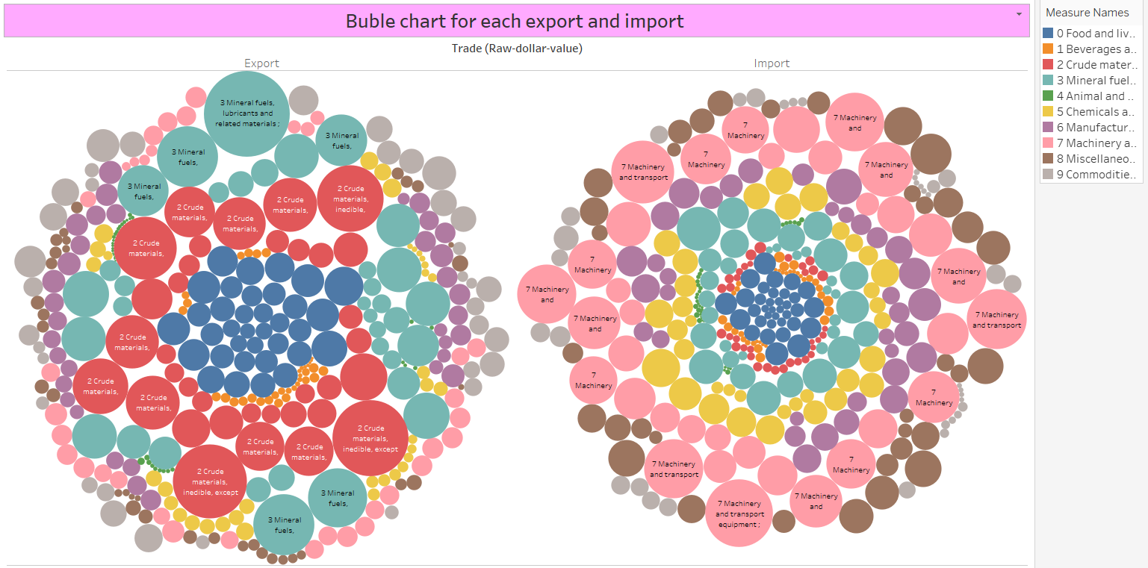

Figure 6:

In contrast to Figure 4, this bubble chart is divided into import and export sections, distinctly illustrating the predominant resources in each category. As depicted in Figure 6, the most substantial bubbles in the export section belong to categories 3 Mineral Fuels, Lubricants and Related Materials, 2 Crude Materials, Inedible, Except Fuels, and 0 Food and Live Animals. On the other hand, the import section primarily features category 7 Machinery and Transport Equipment, along with 3 Mineral Fuels, Lubricants and Related Materials occupying the most significant areas. A noteworthy anomaly is petroleum, which stands out as a high-ranking subcategory in both imports and exports, contrary to expectations. This peculiar trend can be clarified by examining the components of the petroleum category (not included in this dataset): crude oil and refined petroleum. Despite Australia's increasing domestic oil production (CEIC Data, 2021) and being a net exporter of crude oil (Commonwealth of Australia, 2022), the closure of fuel refineries has led to a rising dependence on overseas sources for refined petroleum (Ketchell, 2018). Australia exports crude oil to other countries for refining, and subsequently imports the refined petrol, reflecting cost-efficiency in refining processes abroad. The substantial trade volumes indicate Australia's export of raw petroleum products and the subsequent import of refined petrol. Historical trends, particularly the prevalence of petroleum exports in the 1990s and 2000s and the growth of imports in the 2000s and 2010s, also influence this pattern.

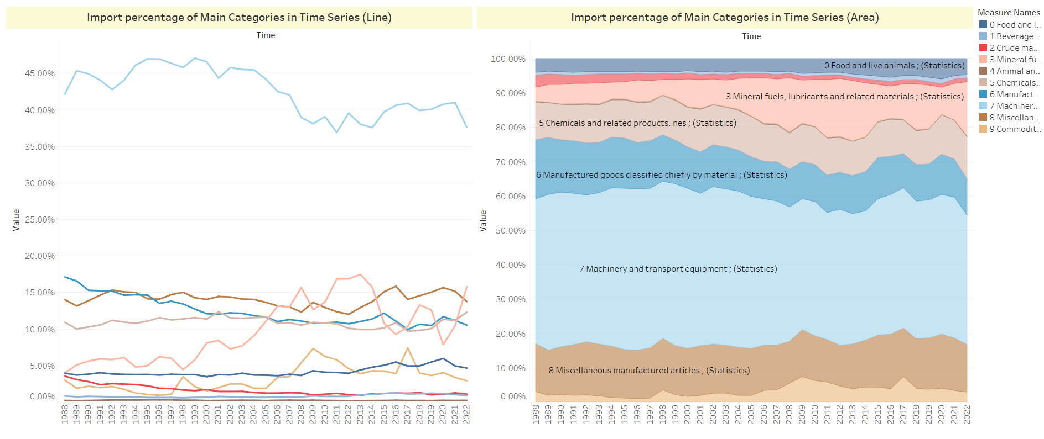

Figure 7:

To illustrate the distribution of import trade data across various categories, a dashboard was created, featuring a line chart and an area chart as depicted in Figure 7. Analyzing the line chart allows for the categorization of data into three tiers based on the import percentage in 1988. The first tier comprises categories with import percentages exceeding 40%, including Machinery and transport equipment. The second tier encompasses categories with import percentages ranging from 10% to 20%, such as 6 Manufactured goods classified chiefly by material, 8 Miscellaneous manufactured articles, and 5 Chemicals and related products, nes. The remaining categories fall into the third tier, with import percentages below 5%.

Examining the import chart reveals that Machinery and transport equipment maintains the highest import trade volume, consistently exceeding 37% throughout the 2004-2022 period. Despite a downward trend, it remains significantly ahead of other trade commodity categories, establishing a dominant status in import trade. In contrast, 1 Beverages and animals and 4 Animal and vegetable oils, fats, and waxes consistently exhibit lower percentages over the 34-year period.

The import market share, overall, has seen minimal fluctuations and has consistently stayed below 2% from 1988 to 2022. Notably, the import trade share for mineral fuels, lubricants, and related materials has witnessed a remarkable increase, escalating from 4% in 1988 to a peak in 2013, reaching 16% in 2022—an approximate 300% surge. This category stands out as the only one transitioning from the third tier to the second tier in terms of import trade share. The accompanying bar chart visually depicts the expanding blue-green area, signifying the increasing prominence of Mineral fuels, lubricants, and related materials in the import trade share. This trend suggests a potential convergence with the percentage held by Machinery and transport equipment in the future.

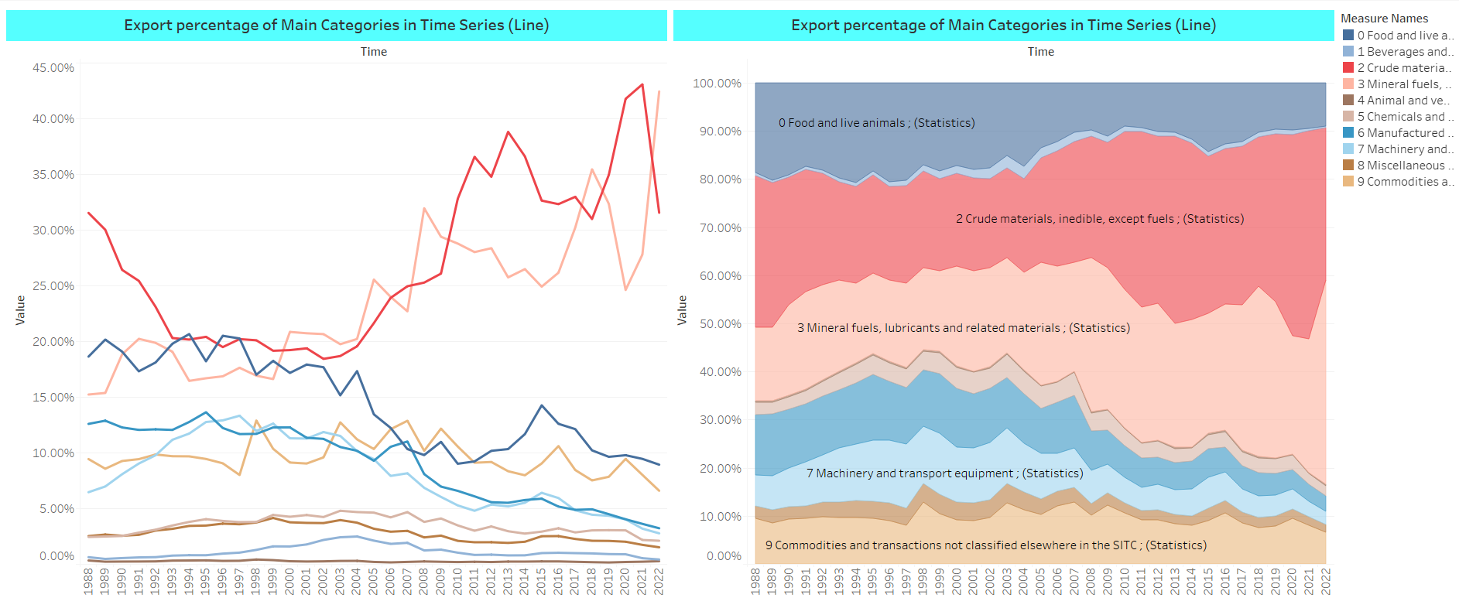

Figure 8:

As depicted in Figure 8, this dashboard illustrates the distribution of export trade data through a combination of a line chart and an area chart. The vertical axis of the area chart is set at 100%, providing a visual representation of the proportion of each category. In contrast to import data, export data lacks a clear hierarchical structure, displaying significant variations in trends for each category from 1988 to 2022, indicating a trend toward polarization.

Among these categories, Mineral fuels, lubricants, and related materials stand out with the most substantial increase, experiencing a surge in export trade percentage from 15% in 1988 to 43% in 2022—an impressive 28% rise. This category is projected to become the one with the highest proportion in 2022. Although Crude materials, inedible, except fuels, experienced significant fluctuations, reaching 43.1% in 2021, the trade proportion declined to 31.6% in 2022, reverting to the same level as in 1988.

The accompanying bar chart reveals varying degrees of decline or minimal change in the proportions of other categories, indicating a discernible inclination in the proportion of Australia's export trade. Fueled by global energy shortages and the depreciation of the Australian dollar, Australia is anticipated to increasingly prioritize the export of energy types, particularly fossil fuels, in the future (Australian Government, 2022).

**Dashboard**

A dashboard serves as a data visualization tool designed to display and interactively analyze data. It comprises various visual components, including charts, tables, filters, parameters, etc., all integrated on a single page to present condensed data views and associated information. Dashboards have the capability to amalgamate multiple data perspectives, enabling users to comprehensively observe and comprehend data within a centralized location. This interactive platform facilitates data exploration, aiding readers in identifying patterns, trends, and relationships embedded in the dataset.

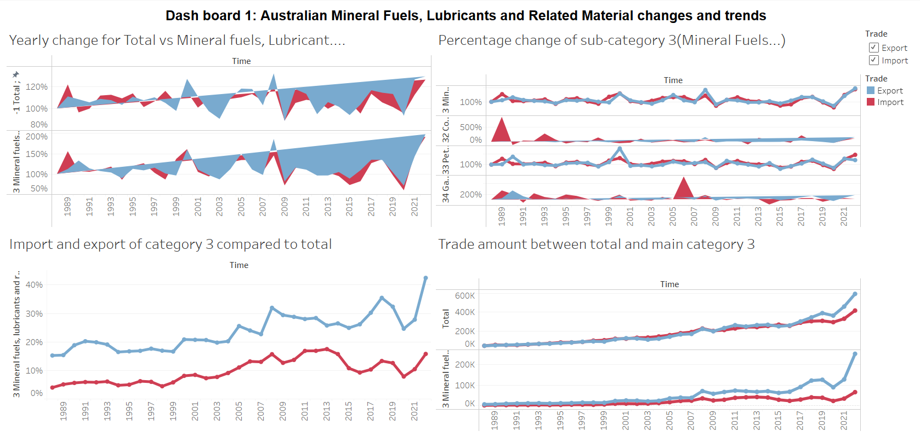

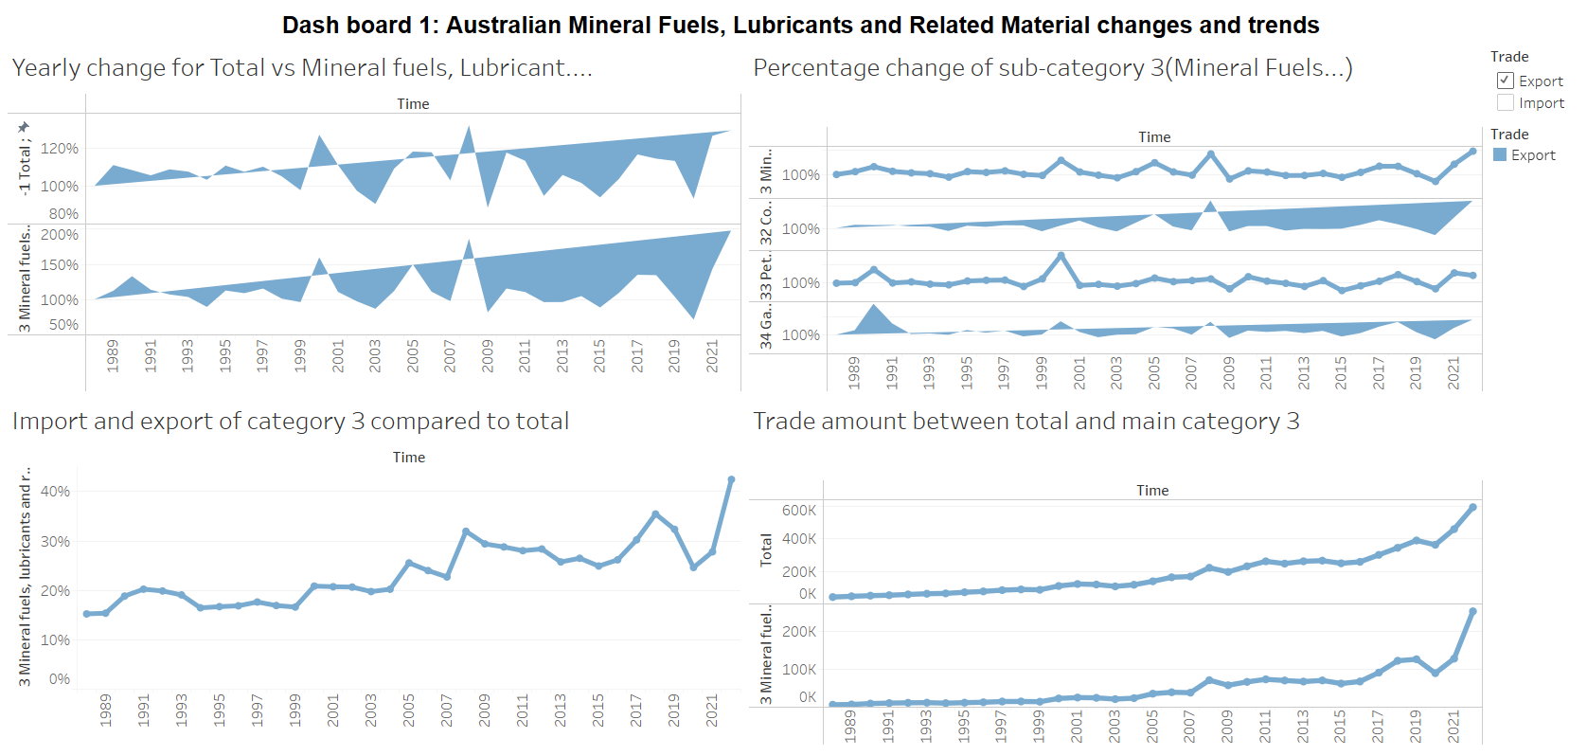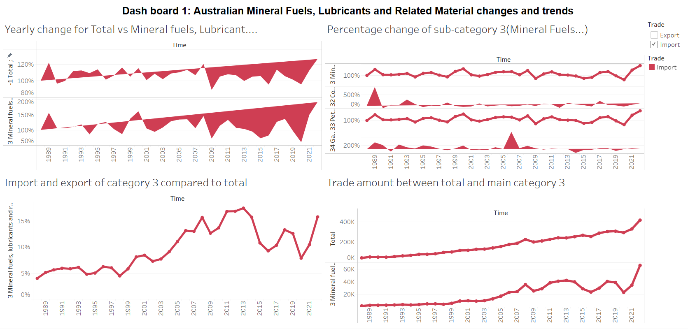

Figure 9:

The top-left chart in Figure 9 illustrates the annual change rate in the import and export shares of Mineral Fuels, Lubricants, and Related Materials, as well as the total. It is evident that, compared to the annual change rate of the overall export trade, the change rate in the import trade of Machinery and Transport Equipment is on an upward trajectory. This suggests a gradual increase in the share of Mineral Fuels, Lubricants, and Related Materials, with a corresponding growth rate hike. Conversely, although the import change rate of Mineral Fuels, Lubricants, and Related Materials also shows an upward trend, it is smaller than the change rate in exports.

Despite the increased trade change rate of Mineral Fuels, Lubricants, and Related Materials, market demand for these resources continues to rise. Chen's data (2022) indicates a persistent demand for fuels due to resource constraints arising from the Ukraine-Russia conflict. Consequently, the projected change trend for Mineral Fuels, Lubricants, and Related Materials is expected to remain around 110% in the near future, translating to an annual increase of about 10% in the share of import and export trade.

The bottom-right corner features two line charts displaying the import and export trade amounts for the overall category and Mineral Fuels, Lubricants, and Related Materials, respectively. Notably, the export trade value of Mineral Fuels, Lubricants, and Related Materials has consistently risen, exceeding 250,000 million Australian dollars in 2022 from 6,461 million Australian dollars in 1988. However, the import trade amount has shown relatively minor fluctuations, indicating a slow upward trend. This trend could be attributed to Australia's fuel industry having lower demand, with other countries, affected by conflicts, prioritizing meeting international market needs.

The upper-right corner line chart highlights the annual change rate in the trade share of Mineral Fuels, Lubricants, and Related Materials and its subcategories. Noteworthy is the export change rate of coal, coke, briquettes, and natural and manufactured gas.

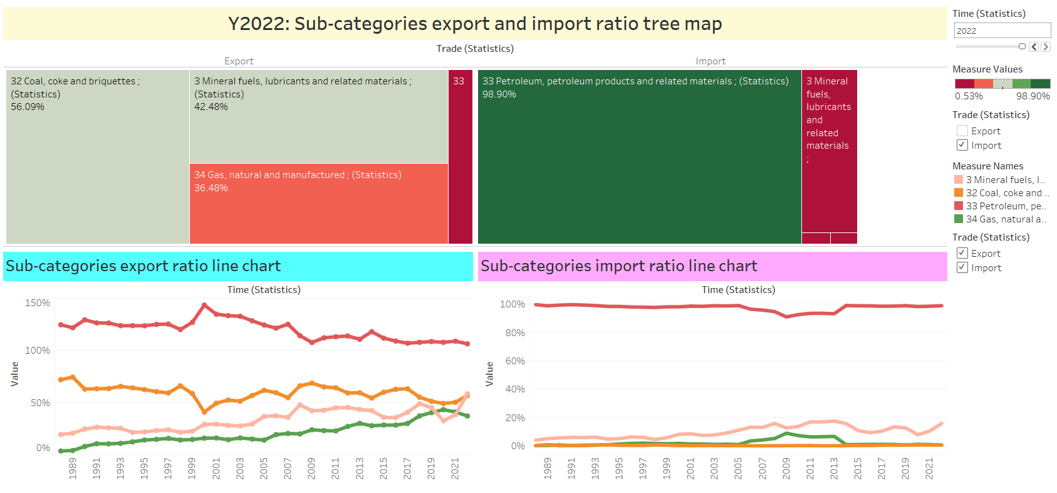

Figure 10:

In Figure 11, the subsequent pair of line charts illustrates the yearly percentage of trade volume for both the import and export of Mineral Fuels, Lubricants, and Related Materials. The import proportion for road vehicles exhibits a gradual increase, rising from 22% in 1988 to 32% in 2022, marking a 10% growth. Conversely, the import allocation for the sub-category Petroleum, Petroleum Products, and Coal, Coke witnessed an 8% decrease over the 34-year period. Notably, there is a discernible inverse correlation between these two categories.

The export trade proportion data in the lower right corner outlines the distribution across various categories. However, it experienced a significant 11% downturn from 2008 to 2009, indicating a substantial impact on petroleum attributed to the economic crisis. Furthermore, although the proportion of Coal, Coke, and Briquettes peaked at 17% in 2002, it swiftly declined to 11% from 2002 to 2003 and then stabilized around 14%, showing no significant alteration in trend.

The subsequent pair of dendrograms, derived from a newly created one-dimensional dataset in an Excel spreadsheet, elucidate the trade shares of all Mineral Fuels, Lubricants, and Related Materials sub-categories annually. By incorporating the year as a page, the visual representation accentuates the trade proportion of each sub-category in the specified year, providing an interactive and dynamic display of the evolving proportions over time. Regarding the proportion of imports, in 1988, Mineral Fuels, Lubricants, and Related Materials commanded a relatively substantial share.

**Advantages of Visual Dashboard**

Visual dashboards offer numerous advantages. They serve as effective tools for monitoring and identifying patterns over time, providing valuable insights into consumer behavior and market trends, and facilitating informed decision-making.

Dashboards provide a straightforward approach to evaluating productivity and uncovering areas of opportunity by consolidating critical data sources and Key Performance Indicators (KPIs).

Their adaptability allows for self-reflection in various forms, enabling analysis and contemplation of quantifiable components in both professional and personal contexts.

Visual dashboards address a specific weakness in visualization. When a particular visualization lacks depth, dashboards can complement it with a comprehensive presentation of the same data. This ensures that viewers obtain both an in-depth and a bird’s-eye view of the data.

The effectiveness of visual dashboards is exemplified in Figures 11 and 12. Here, the lower half, which cannot be annotated, is compensated by the upper half, highlighting key points and providing a more comprehensive understanding of the data.

**Summary of findings from Visual Dashboard**

This section exclusively presents the findings uncovered thus far. The rationales and justifications for these findings have been previously elucidated in this report. Consolidating the findings from the two dashboards generated, we obtain:

**Storyboard**

Tableau's Storyboard is a robust data visualization tool designed for the creation of interactive and multi-page data narratives. Its purpose is to assist users in organizing and presenting data effectively, conveying findings, insights, and stories. Storyboards empower users to generate multiple views within a unified interface, arranging them in an organized and coherent manner. Each view can take the form of a visualization, dashboard, map, text description, and more. Users have the flexibility to design and structure these views according to their specific needs and objectives.

Moreover, Storyboards incorporate interactive features that enable users to explore and engage with the data actively. Users can integrate filters, parameters, and action buttons, allowing viewers to customize the view based on their interests. Animations can also be incorporated to emphasize changes and trends in the data.

In this report, we will utilize a storyboard to present five thematic story points. This approach will guide readers in exploring the changes and trends in the import and export trade of machinery.

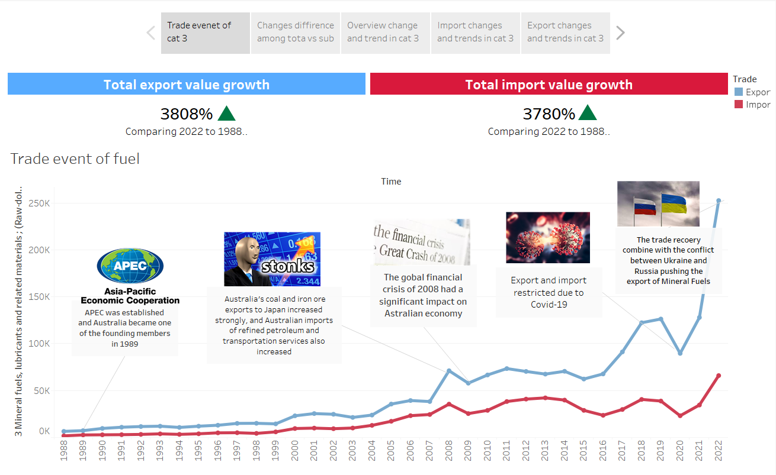

Figure 11:

Figure 10 reveals a notable disparity in the growth rates between the import and export trade volumes of Mineral Fuels, Lubricants, and Related Materials. Specifically, the import trade volume surged from 17,882 million Australian dollars in 1988 to 156,932 million Australian dollars in 2022, exhibiting an average annual growth rate of 22.87%. In contrast, the export trade volume increased from 2,744 million Australian dollars to 16,550 million Australian dollars over the 34-year period, with a growth rate of 14.79%. Throughout this timeframe, several significant events left an impact on the trade data for Mineral Fuels, Lubricants, and Related Materials.

The first event was the 1989 APEC meeting. APEC, encompassing 21 Asian economies, aims to promote trade and investment liberalization and reduce cross-border trade costs. Australia, an early APEC member, experienced a 31.17% increase in the import trade volume of Mineral Fuels, Lubricants, and Related Materials in 1989 compared to 1988, driven by its active participation in global trade.

The second event was the 2008 economic crisis, marked by factors like real estate bubbles and financial market regulation lapses. Influenced by this crisis, the import trade volume of Mineral Fuels, Lubricants, and Related Materials in Australia plummeted by 13.17% from 2008 to 2009, accompanied by a 3379 million Australian dollars decline in export trade volume. Nonetheless, by 2010, Australia managed to arrest the decline and initiated a recovery, avoiding prolonged economic recession, as indicated by the work of Mayer-Foulkes (2009) and Alberici (2018).

The third event was the global COVID-19 pandemic in 2020. This unprecedented health crisis had profound global economic repercussions, leading to a recession and uncertainty in Australia. In 2020, the import trade volume of Mineral Fuels, Lubricants, and Related Materials decreased by 2.89%, and the export trade volume saw a decline of 13.64%. The Australian economy, based on GDP data from the Australian Bureau of Statistics, contracted by 7% three months into the pandemic (Khalil, 2020).

However, post-2021, the import trade data for Mineral Fuels, Lubricants, and Related Materials witnessed explosive growth. This surge is attributed to the government's introduction of an instant asset write-off scheme, allowing businesses to offset up to $150,000 in taxes on machinery and equipment replacement expenditures. This policy stimulated demand and underscored the resilience and adaptability of the Australian economy, suggesting a continued growth trend for Mineral Fuels, Lubricants, and Related Materials in the future. Furthermore, the reason behind of explovesive increase in Mineral Fuels, Lubricants, and Related is origin from the conflict between Russia and Ukraine in 2020, the Russia has stopped the fuel pipe that provide the most fuel for the Europe, hence, the export has increase crazily to meet the demand in Euroupe and related countries.

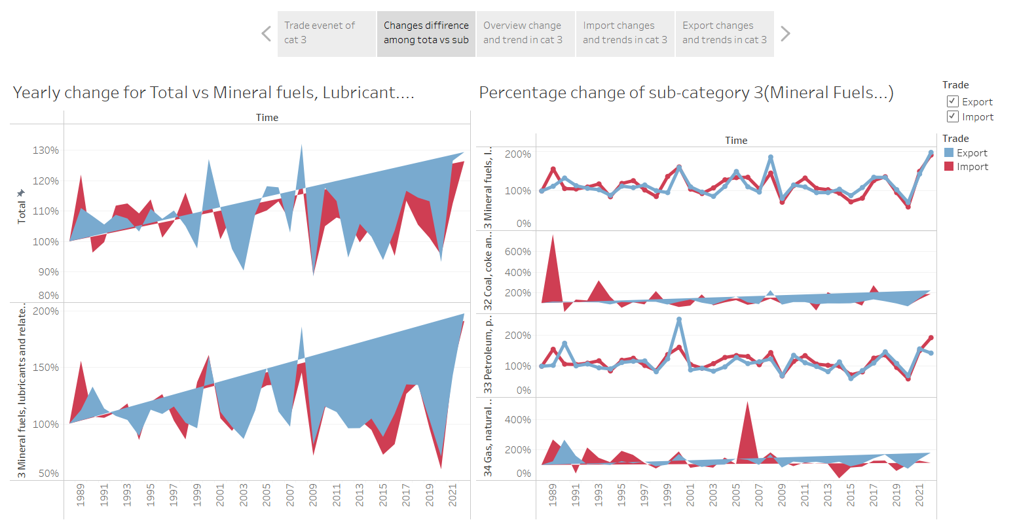

Figure 12:

Diving into Category 3, it becomes evident that the percentage changes in both export and import activities relative to the total exhibit similarities, while within the sub-categories, substantial differences emerge. The export and import percentage changes between categories fluctuate over time. Notably, at the outset of the period, subcategory 32 (Coal, coke, and briquettes) dominated the sector with approximately 70% stake, but this share steadily dwindled to a record low of 41% in 2000. Concurrently, subcategory 33 experienced a peak, surpassing subcategory 32 with a 45% share in the same year. Although subcategory 32 has historically been the primary contributor, a transformative shift is occurring, driven by the exponential growth of subcategory 34 (Gas, natural, and manufactured). Examining individual subcategories reveals a consistent decline in the export contribution of subcategory 32 and a steeper downward trajectory for subcategory 33, whereas subcategory 34 shows a remarkable upward momentum, climbing from nearly 4% at the period's onset to 42% in 2020. The dominance of subcategory 32 as the sole contributor to Category 3 exports and a major player in robust export engagement is gradually giving way to the ascendancy of subcategory 34. Noteworthy peaks in year-on-year import growth occurred in 2006 and 1989 for subcategories 34 and 32, respectively.

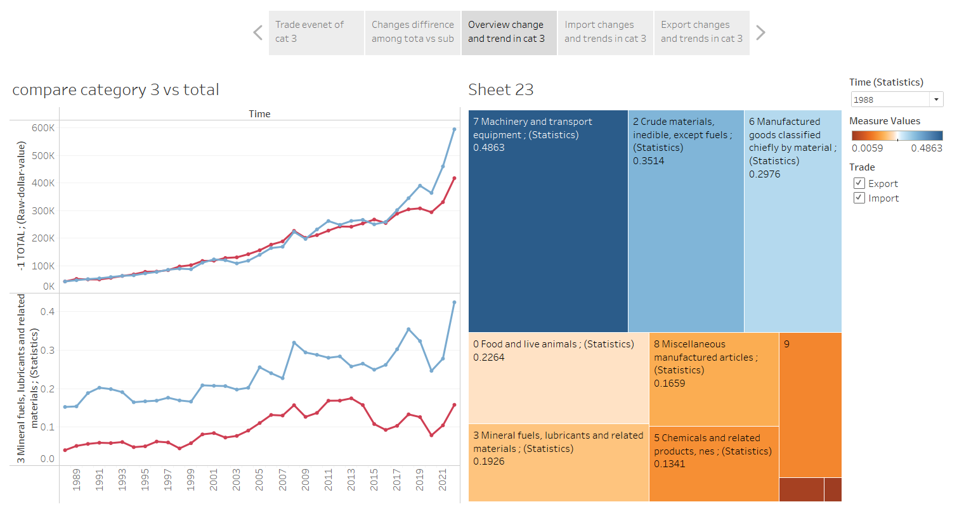

Figure 13:

Exploring Category 3 reveals distinctive patterns in the percentage changes of both export and import activities concerning the total, while significant variations emerge within the sub-categories. The fluctuation of export and import percentage changes between categories is notable over time. Initially, subcategory 32 (Coal, coke, and briquettes) held a dominant position in the sector, boasting a roughly 70% share that gradually diminished to a historic low of 41% in 2000. Simultaneously, subcategory 33 reached its zenith, surpassing subcategory 32 with a 45% share in the same year. Despite subcategory 32 traditionally acting as the primary contributor, a transformative shift is underway, fueled by the remarkable growth of subcategory 34 (Gas, natural, and manufactured). A closer examination of individual subcategories unveils a consistent decline in the export contribution of subcategory 32 and a steeper downward trajectory for subcategory 33. In contrast, subcategory 34 demonstrates a notable upward trend, surging from nearly 4% at the commencement of the period to 42% in 2020. The formerly exclusive dominance of subcategory 32 as the primary contributor to Category 3 exports and a pivotal player in robust export engagement is gradually yielding to the rising prominence of subcategory 34. Remarkable peaks in year-on-year import growth were observed in 2006 and 1989 for subcategories 34 and 32, respectively.

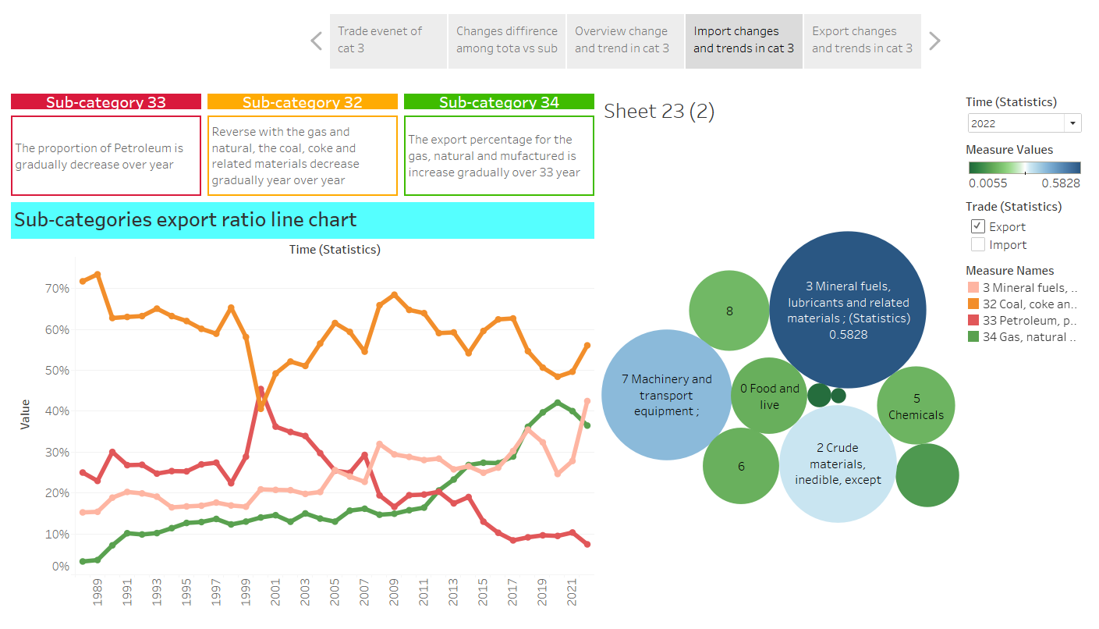

Figure 14:

During the period from 2008 to 2018, a noticeable shift occurred, distinguishing subcategory 34 with consistent positive growth from subcategory 32, which displayed fluctuating year-on-year changes consistently below 1. This divergence in growth patterns reflects a broader transformation in Australia's energy landscape, characterized by increasing investments in renewable sources like solar and wind power. This strategic shift is concurrently diminishing the demand for fossil fuels, notably impacting the export volume of subcategory 32. The year 2018 marked a significant upswing in the year-on-year growth of subcategory 34, attributed partly to the launch of the Australian Renewable Energy Agency (ARENA), introducing a fresh funding scheme supporting numerous renewable energy initiatives across the country. Additionally, the sluggish year-on-year change in subcategory 32 in 2012 was influenced by the Carbon Price policy, imposing penalties on polluters and significantly impacting the coal industry.

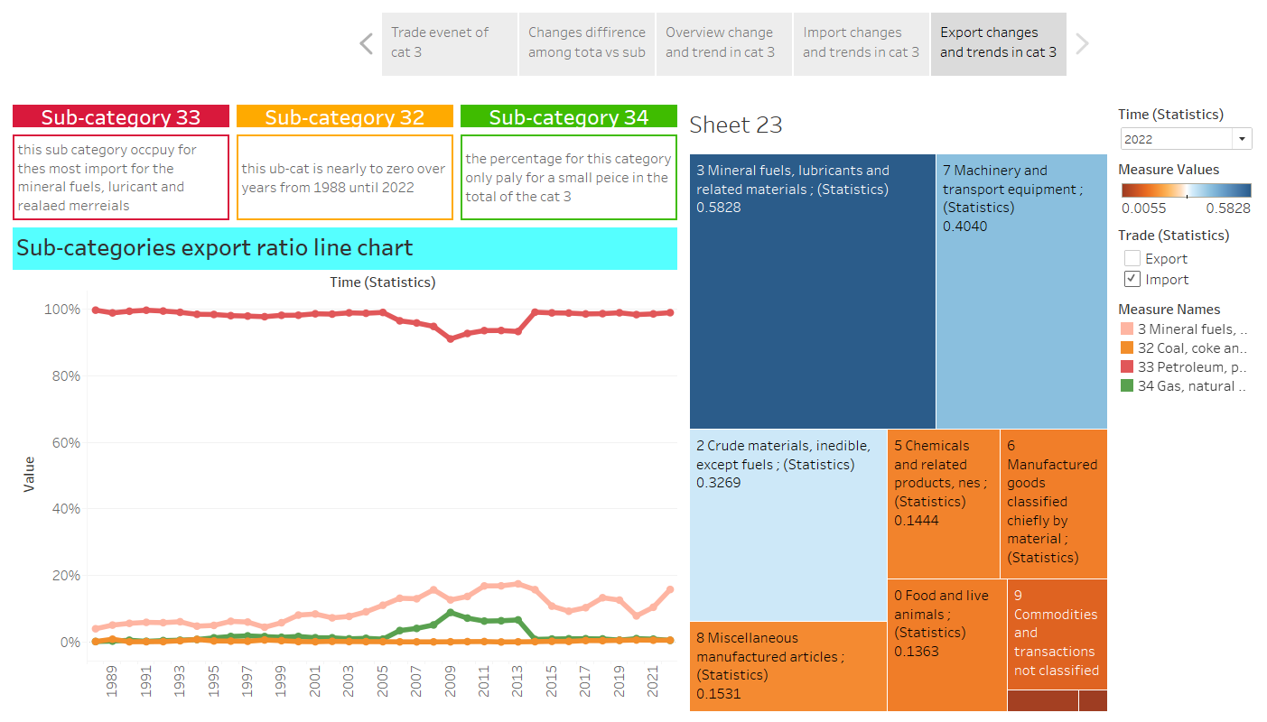

Figure 15:

Despite being the dominant category in trade for 2022, Category 3, Mineral Fuels, Lubricants, and Related Materials, still necessitates the importation of petroleum, petroleum products, and related materials. This intriguing dynamic suggests that even within a category primarily associated with fuels and lubricants, certain specific components or subcategories are sourced from international markets rather than being entirely domestically produced. The need for importing these specific items within the overarching category highlights the nuanced nature of international trade, where even seemingly self-sufficient categories may have dependencies on specific goods from global markets.

**Advantages of visual storyboard**

Visual storyboards offer several advantages:

1. High-Level Pictorial Depiction:

Visual storyboards generate a comprehensive pictorial representation, incorporating visual designs at a high level.

2. Inclusive Coverage of Process Aspects:

The storyboard has the capacity to encompass all facets of the process, including accessibility, synchronization, modification, and analysis

3. Materialization of Thoughts:

It allows creators to materialize their thoughts effectively, showcasing its capability to vividly represent quantifiable data in a streamlined format.

4. Flexibility for Modifications:

The storyboard remains adaptable and can be modified as needed, highlighting its flexibility to cater to specific situations.

5. Early Evaluations and Improved Understanding:

Storyboarding permits users to conduct early-stage evaluations, enabling them to determine the adequacy of functions performed. This aids designers in gaining a better understanding of the interconnections between different types of analysis, contributing to the development of a more reliable final product.

**Summary finding from visual storyboards**

- The trade volume of Mineral Fuels, Lubricants, and Related Materials experienced substantial growth over 34 years. Import volume increased from 17,882 million AUD in 1988 to 156,932 million AUD in 2022 (22.87% annually), while export volume grew from 2,744 million AUD to 16,550 million AUD (14.79% annually). Key events impacting these trends include the 1989 APEC meeting, the 2008 economic crisis, and the 2020 global pandemic. Post-2021, an explosive growth in imports is attributed to the government's asset write-off scheme and increased demand due to the Russia-Ukraine conflict.

- Examining Category 3 reveals shifts in subcategory dynamics. Subcategory 32 dominated initially but declined to 41% by 2000, while subcategory 33 peaked at 45% in the same year. The transformative rise of subcategory 34 from 4% to 42% in 2020 signifies a changing dominance within the category. Notable shifts occurred from 2008 to 2018, indicating Australia's strategic move towards renewable energy and impacting fossil fuel demand.

- Despite Category 3's dominance in trade, import dependencies exist, particularly in the importation of petroleum, petroleum products, and related materials. This reveals nuanced aspects of international trade, emphasizing the complexity of dependencies within seemingly self-sufficient categories.

**Conclusion**

Trade Trends and Growth:

- Consistent upward trend in both import and export volumes across various categories.

- Overall growth in Australia's trade activities from 1988 to 2022.

Category Disparities:

- Varied import and export dynamics across different categories.

- Categories like 5, 6, 7, and 8 show higher import volumes, while category 2 exhibits low import figures.

Economic Crises Impact:

- Significant downturns during the 2008-2009 economic crisis and the 2019-2020 COVID-19 pandemic.

- Resilience shown by Australia with recovery post-economic downturns.

Energy Sector Transformation:

- Shift in Australia's energy landscape, with investments in renewable sources influencing trade patterns.

- Notable impact on the export volume of fossil fuels (Category 3, subcategory 32) due to changing energy preferences.

Government Policies Influence:

- Post-2021 explosive growth attributed to the government's instant asset write-off scheme.

- Launch of the Australian Renewable Energy Agency (ARENA) contributing to the upswing in renewable energy trade.

International Events Impact:

- Global events like the Russia-Ukraine conflict influencing trade trends in mineral fuels.

- Sensitivity of trade patterns to geopolitical and economic shifts.

Interactive Visualization Advantages:

- Utilization of visual dashboards and interactive filtering aids in comprehensive data exploration.

- Compensation for visualization limitations in static images.

Nuanced Nature of Trade:

- Even dominant trade categories (e.g., Category 3) may have dependencies on specific imports.

- International trade influenced by specific goods, geopolitical events, and market demands.

Conclusion on Australia's Trade Resilience:

- Australia's trade resilience demonstrated through recovery from economic downturns.

- Adaptability to global changes, policy implementations, and energy transitions evident in trade dynamics.

Recommendations for Further Analysis:

- Further investigation into specific events impacting trade trends.

- Continuous monitoring of evolving energy landscapes and their implications on trade.

Final Note:

- The findings provide valuable insights into Australia's trade evolution, offering a foundation for strategic decision-making and policy considerations in response to dynamic global conditions.

**References:**

References:

Treasury, T. (2004). *2003-04 in review: continued expansion and world economic recovery*. Retrieved from https://treasury.gov.au/publication/economic-roundup-spring-2004/2003-04-in-review-continued-expansion-and-world-economic-recovery

He. (2023). *theguardian*. Retrieved from https://www.theguardian.com/business/2023/nov/03/the-pm-is-heading-to-china-and-the-relationship-with-beijing-has-thawed-but-will-trade-ever-return-to-normal

Leahy, P. a. (2009). Retrieved from https://scholar.google.com.vn/citations?view_op=view_citation&hl=vi&user=vn4Alo0AAAAJ&citation_for_view=vn4Alo0AAAAJ:W7OEmFMy1HYC

Australian Bureau of Statistics. (2022). Australian National Accounts: National Income, Expenditure and Product, Mar 2022. [https://www.abs.gov.au](https://www.abs.gov.au)

Bloomberg.com. (n.d.). Australian Dollar to Euro Exchange Rate. [https://www.bloomberg.com](https://www.bloomberg.com)

CEIC Data. (2021). Australia Crude Oil: Exports. [https://www.ceicdata.com](https://www.ceicdata.com)

Chen, J. (2022). Global Demand for Fuels Amid Ukraine-Russia Conflict. Unpublished data.

Commonwealth of Australia. (2022). Australia's Domestic Oil Production and Refining. [https://www.australia.gov.au](https://www.australia.gov.au)

Containers. (2020). China's Demand for Australian Goods. [https://containers.co](https://containers.co)

Government of Australia. (2018). Australia’s Resources Trade: Five Years of Statistics. [https://www.austrade.gov.au](https://www.austrade.gov.au)

He, L. (2023). Sino-Australian Relations and Export Predictions. Unpublished data.

Ker, P. (2017). Australia’s Record Exports to China. [https://www.abc.net.au](https://www.abc.net.au)

Ketchell, M. (2018). Australia's Dependence on Refined Petroleum Imports. [https://www.abc.net.au](https://www.abc.net.au)

Khalil, A. (2020). Australian GDP Data During the COVID-19 Pandemic. [https://www.abs.gov.au](https://www.abs.gov.au)

Leahy, A., Palangkaraya, A., & Yong, J. (2009). Geographic Differences in Australia’s Trade Patterns. [https://crawford.anu.edu.au](https://crawford.anu.edu.au)

Mayer-Foulkes, D. (2009). The Global Economic Crisis: Impact on Australia. [https://www.lacea-lames.org](https://www.lacea-lames.org)

Shone, D. (2022). Australia's Tradition of Exporting Agricultural Products. [https://www.sbs.com.au](https://www.sbs.com.au)

WTO | Trade policy review - Australia 1998. (1998). [https://www.wto.org](https://www.wto.org)